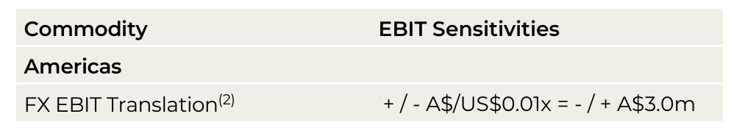
(2) Based on the actual 1H26 Dyno Nobel Americas statutory EBIT of US$68.1m and then annualised and an average foreign exchange rate of AUD:USD 0.67.

